**Sumatran Hornbill as an Idea for Creating Paintings**

Lalang Cakra Buana1)*, Muslim Muslim2), Azmi3), Khaerul Saleh4), Nelson Tarigan5), Tifan Muhammad Amirulloh6), Sugito7)

1,2,3),4),5),6),7) Fine Arts Education, Faculty of Languages and Arts, Universitas Negeri Medan, Indonesia

*Corresponding Author

Email : [lalangcb21@gmail.com](mailto:lalangcb21@gmail.com)

***How to cite*:** Buana, L. C., Muslim, M., Azmi, A., Saleh, K., Tarigan, N., Mirulloh, T. M., & Sugito, S. (2024). Sumatran Hornbill as an Idea for Creating Paintings. *Gorga : Jurnal Seni Rupa*, *13*(2), 824-829. https://dx.doi.org/ 10.24114/gr.v13i2.55753

***Article History :*** *Received: October 18, 2024. Revised: October 27 , 2024. Accepted: December 31, 2024*

|  |  |  |
| --- | --- | --- |
| **ABSTRACT** |  | KEYWORDS |
| The creation of this work is driven by the author’s profound interest in hornbills, particularly given the alarming rate of their extinction. The author’s objective is to convey the aesthetic significance of this animal to the broader community. The Sumatran hornbill, with its distinctive and striking characteristics, including its large beak, robust claws, and vibrant plumage, serves as the subject matter for this study. Through the meticulous application of acrylic paint on canvas, the author has crafted twelve paintings that meticulously capture the physical attributes of the bird and its natural habitat. Furthermore, these paintings depict the hornbill’s omnivorous lifestyle. The author employs a combination of three distinct techniques: plaque, chiaroscuro, and bravura. These techniques work synergistically to create a dynamic, contrasting, and vivacious portrayal of the hornbill within the paintings. The resulting twelve paintings, each bearing a unique title that reflects the author’s interpretation of the hornbill, provide an in-depth understanding of its physical characteristics, habitat, and behavior. Additionally, these works contribute to the advancement of the art form through the author’s unique perspective and creative expression. |  | Fine art, Burung Rangkong, Sumatran Hornbill, Painting  This is an open access article under the [CC–BY-SA](http://creativecommons.org/licenses/by-sa/4.0/) license |

**INTRODUCTION**

The Sumatran hornbill (Buceros rhinoceros) is one of the endemic species that inhabits the island of Sumatra, Indonesia. This bird has an important role in the ecosystem as a seed disperser and maintainer of environmental balance. However, the existence of Sumatran hornbills is now under serious threat. Based on the International Union for Conservation of Nature (IUCN) red list, this bird is classified as an endangered species due to various factors, such as illegal trade, poaching, habitat loss due to deforestation, and conflicts between humans and wildlife. This threat not only threatens the sustainability of the Sumatran hornbill population, but also damages the Sumatran ecosystem where it lives.

In addition to its role in the ecosystem, the Sumatran hornbill has significant cultural and spiritual value for several indigenous communities in Sumatra. The physical uniqueness of this bird, with its large beak and horns typical of males, as well as its attractive lifestyle behavior, make it a symbol of biodiversity that needs to be preserved. However, this conservation effort requires a creative approach that is able to touch the awareness of the wider community.

A number of previous studies have addressed topics related to hornbills and their conservation. A study conducted by Hadiprakarsa et al. (2019) highlights the role of hornbills as the main seed disperser in tropical forests and how the loss of these species can trigger ecosystem degradation. Another study by Noverita and Purwanto (2021) examines the importance of a community-based approach in the conservation of Sumatran hornbills through collaboration between indigenous institutions and conservation organizations. Meanwhile, Dewi et al. (2022) discussed the use of digital media in increasing public awareness of the importance of hornbill conservation, focusing on the effectiveness of visual campaigns on social media.

However, until now there have not been many studies that link visual arts, especially painting, with efforts to preserve Sumatran hornbills. Previous studies have focused more on biological, ecological, and digital approaches to conservation, while the potential of visual arts as a communication medium to reinforce conservation messages has not been explored in depth. This research attempts to fill this void by exploring how painting can be used as a tool to increase public appreciation of the Sumatran hornbill and, at the same time, contribute to the preservation of local culture and ecosystems.

In an effort to increase awareness of the importance of preserving Sumatran hornbills, painting can be an effective medium. Painting is not only a form of individual expression, but also a powerful means of visual communication to convey the message of preservation to society. The visual uniqueness of the Sumatran hornbill makes it an interesting subject in painting, both in a realism style that emphasizes details, and surrealism that combines reality and imagination.

This research aims to describe the process of creating paintings with Sumatran hornbills, explore the aesthetic value in the depiction of this bird, and convey a message about the beauty and importance of species conservation through the medium of art. The paintings are expected to not only be a representation of the beauty of Sumatran hornbills, but also contribute to environmental conservation efforts and encourage appreciation for biodiversity and local wisdom in Sumatra.

**METHOD**

The creation method is a process used in creating works of art with certain purposes and uses. In the context of painting research, Hendriyana (2021) identifies two main variables, namely content variables and process variables. Content variables involve ideas, concepts, values, and aesthetic meanings, while process variables relate to ideas, concepts, functions, materials, techniques, and artistic forms. According to Hendriyana (2021), the purpose of creation must be designed with reference to a specific topic and reflect the actions and activities of scientific answers. The main object of the work being researched did not exist when the research began, so that in the creation process, the components and elements of creation were designed in accordance with the intended goals and benefits. This process involves collecting relevant data and theories that support the realization of the work. The process of creating paintings involves four main stages, namely preparation, elaboration, contemplation, and realization of the workThe creation of this work is carried out at the Baginda Sirait Fine Art Gallery, Medan State University, which is located at Jl. William Iskandar Ps. V, Medan Estate, Percut Sei Tuan District, Deli Serdang Regency, North Sumatra. The number of works created is 12 paintings. The division of works is for sizes 100x100cm and sizes 80x100cm. The results of this creation will be exhibited at the Baginda Sirait Fine Arts Gallery, Medan State University in January 2024.

**RESULT AND DISCUSSION**

In making this work, the author chooses images from several objects and subjects related to the theme of painting Creation Research, the images are used by the author as a laboratory to find visual concepts that can channel or represent the author's visual concepts. The number of works created in this study is 12 paintings but 3 of them are as follows.

1. **Beautiful Person**

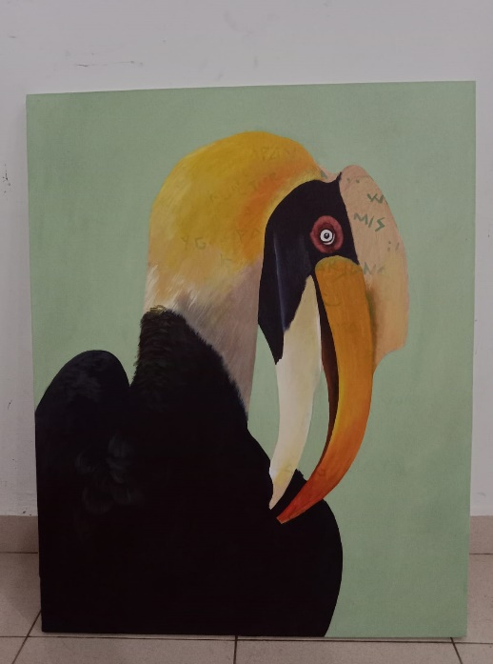

**Figure 1.** Beautiful Person

Media: Acrylic paint on canvas

Size : 80 x 100 cm

Year :2023

(Source: Lalang Cakra Buana, 2023)

The painting brings beauty and intimacy in a seemingly simple but meaningful moment when a hornbill gently scratches its feathers. The movement of the beak that touches the feathers with smoothness and precision creates an impression of peace and well-being. In the context of aesthetic theory, this moment can be analyzed through Edmund Burke's view of sublime and beautiful. Burke defines beautiful as something alluring because of its softness, subtlety, and ability to create serenity. This scene, with subtle movements captured in detail, highlights the beautiful aspects that can captivate the audience.

The scratched feather detail is an important element that gives texture and dimension to this work. By displaying realistic variations of colors and textures, the artist creates visual depth that allows the viewer to feel the bird's presence in real life. This is in line with the theory of realism in art which emphasizes the depiction of objects with high accuracy to reflect reality. The touch of light on the shimmering feathers adds a sense of life, creating a stunning three-dimensional effect.

The expression on the hornbill's face, if displayed with a focus on detail, reflects enjoyment and serenity. This is in line with Rudolf Arnheim's view in visual art theory, which states that art not only represents objects, but also expresses emotions and experiences. Through the facial expressions of birds, the artist manages to convey a peaceful atmosphere that goes beyond just physical representation.

The background of the painting, which may consist of natural elements such as leaves or the sky in soft colors, is designed to reinforce the focus on the main subject without distracting the attention. According to gestalt theory, a supportive background can reinforce the figure-ground principle, where the main subject is seen more prominently because of the contrast with the background. This creates a harmonious composition and draws the viewer's attention to the hornbill as the center of the visual narrative.

The soft color palette used in this painting reflects harmony and harmony. The use of neutral or pastel colors to create a calm atmosphere reflects an approach in color theory by Johannes Itten, which emphasizes how certain colors can evoke certain emotions. In this case, the soft colors create a feeling of peace, inviting the audience to reflect on the simple but profound beauty of natural life.

With this approach, the painting becomes not only a visual representation of a hornbill taking care of its feathers, but also a statement of peace and beauty of nature. The painting reminds the viewer of the ecological and spiritual values that can be found in every small moment in nature, as well as being an effective medium to convey the message of conservation through an immersive aesthetic experience.

**2.****Strength and Beauty**

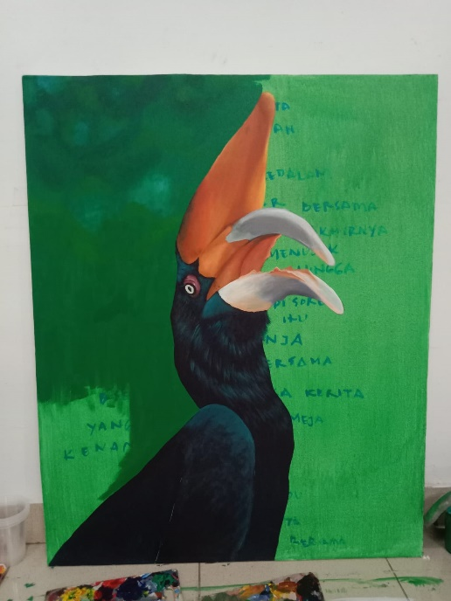

**Figure 2.** Strength and Beauty

Media: Acrylic paint on canvas

Size : 120 x 80 cm

Year :2023

(Source: Lalang Cakra Buana, 2023)

The painting mesmerizes by capturing the dramatic moment when the hornbill opens its beak, a representation that not only presents visual beauty but also conveys a profound symbolic message. The dynamic movements captured in this painting reveal the essence of the hornbill's strength and elegance, with exquisite detail depicting every aspect of the anatomy of its beak. Textures and details such as water droplets or dew sticking to the beak add an element of life and realism to the painting, making it more than just a static image, but a vivid visual narrative.

The depiction of expressions in the hornbill's eyes that reflect emotions such as excitement, ferocity, or surprise, shows how art is able to be a medium for conveying the complexity of feelings and moods. A carefully chosen background, perhaps in the form of natural elements such as a twilight sky or a lush tropical forest, provides a context that reinforces the dramatic message. Artists can use contrasting colors to accentuate the main subject and create a unique atmosphere, such as a magical or mysterious atmosphere. The play of light and shadow, applied with precision, adds a dramatic dimension to the painting, creating a visual depth that invites the viewer to engage further with the work.

In this analysis of art, Edmund Burke's aesthetic theory of sublime is very relevant. Burke explains that beauty is often associated with feelings of awe and respect that arise from something big, powerful, or unreachable. The hornbill painting depicting this dramatic moment creates a feeling of sublimation through a combination of power and beauty depicted with high precision. Details such as water droplets or dew on the beak and the emotional expression of the bird illustrate the ability of art to deliver a profound and transcendent visual experience.

In addition, Roland Barthes' semiotic theory is also relevant in understanding the symbolic meaning contained in this painting. The hornbill's open beak can be interpreted as a symbol of the power of sound or communication in the wild, reflecting the important role this bird plays in the ecosystem. The background elements and colors used by the artist can be thought of as visual codes that form a narrative about the relationship between hornbills and their environment.

1. **Beauty Gaze**

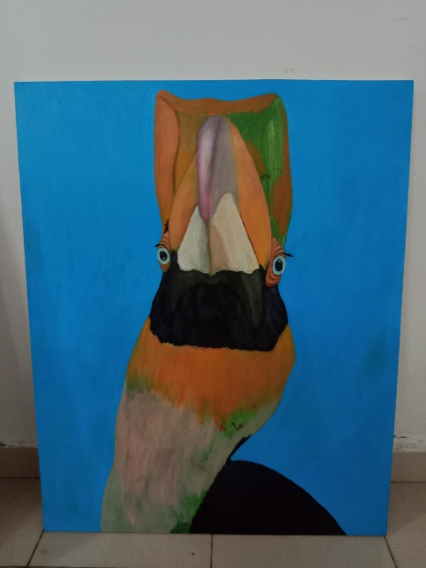

**Figure 3.** Beauty Gaze

Media: Acrylic paint on canvas

Size : 80 x 120 cm

Year :2023

(Source: Lalang Cakra Buana, 2023)

This epic painting depicting hornbills with majestic poses and graceful expressions presents an immersive visual experience for its connoisseurs. Every visual element in this piece, from the texture of the fur to the play of colors, contributes to creating an aura that symbolizes freedom, beauty, and the power of nature. Hornbills, with feathers depicted like silk, provide a symbol of nature's fragile yet alluring harmony. Through a focus on the bird's sharp eyes, the painting manages to create the illusion of direct interaction between the artwork and the viewer, as if the bird is able to penetrate the dimensions of space and time to convey a message of preservation and hope.

The analysis of this work can be approached through Immanuel Kant's aesthetic theory, which views art as a subjective experience capable of evoking a sense of beauty and sublimity. In the context of this painting, the use of visual elements such as texture, color, and expression produces a profound aesthetic effect, in accordance with what Kant calls beauty and sublime. The combination of realistic details and imagination that brings the subject of this painting to life allows the viewer to feel a sense of admiration (awe) for the beauty of the hornbill and awareness of its importance in nature.

Furthermore, Roland Barthes' semiotic theory can be used to understand how meaning and message are constructed in this artwork. According to Barthes, the symbols and signs in a work of art carry meanings that can be interpreted by the viewer based on their experiences and social context. In this painting, the hornbill's eyes depicted with incredible sharpness become a sign that exudes a message of strength and environmental awareness, while the silk-like feathers reflect the subtle but precious symbolism of life. The ecological context of the Sumatran hornbill as an endangered species further strengthens the symbolic meaning of this work.

Additional references from Susanne K. Langer in Philosophy in a New Key (1942) may also support this analysis. Langer emphasized that art is a symbolic way of communication that is different from verbal language, but no less effective in conveying emotional experiences and intuitive understanding. In this hornbill painting, a powerful visual technique conveys a message of preservation without the need for a verbal narrative, making it a universal medium to touch the viewer's environmental awareness.

By referring to these theories, hornbill paintings became more than just visual representations; It is a complex communication medium that combines aesthetics, symbolism, and ecological messages to arouse attention and empathy for nature conservation.

**CONCLUSIONS**

The epic painting of hornbills depicted with elegance and visual power has managed to become an effective medium to convey the message of environmental conservation. By leveraging Immanuel Kant's aesthetic theory, Roland Barthes' semiotic theory, and Susanne K. Langer's symbolic communication perspective, this work shows how visual art can integrate aesthetic value and symbolic meaning to create an immersive experience for the audience. The combination of coloring techniques, realistic details, and imaginative elements not only creates beauty, but also conveys a subliminal message about the importance of protecting endangered species such as the Sumatran hornbill. This painting is proof that art has great potential as a universal communication tool and is able to build ecological awareness.

For the next study, it is suggested to explore how the audience's response to visual arts with conservation themes can be measured more quantitatively, for example through surveys or interviews. Additionally, a cross-disciplinary approach involving ecologists, anthropology, and the arts can enrich an understanding of how hornbill symbolism is accepted in the context of local cultures. The use of digital media to expand the impact of visual messaging also needs to be explored further, given the great potential of digital platforms in reaching a wider audience.

**REFERENCES**

Barthes, R. (1968). Elements of Semiology. Paris: Farrar, Straus and Giroux

Burke, E. (1792). A Philosophical Enquiry into the Origin of Our Ideas of the Sublime and Beautiful. Universitas Lausanne: J.J. Tourneisen.

Djawad, Alimuddin A. (2019). Pesan, Tanda, dan Makna dalam Studi Komunikasi. *Statistika: Jurnal Bahasa, Sastra, dan Pengajarannya. 4(2), 95-101*.

Hendriyana, M. (2019). *Metodologi Penelitian Penciptaan Karya*. Bandung: CV. Pilar Nusantara.

Kamal, S., Agustina, E., & Azhari. (2018). Populasi burung rangkong badak (Buceros Rhinoceros) di ekosistem Tahura Pocut Meurah Intan, Provinsi Aceh. *Jurnal Biotik, 6(1), 11-16.*

Kanisius. (1997). *Seni Lukis: Panduan bagi Pelukis Pemula*. Yogyakarta: Kanisius.

Kartika, Dharsono Sony. (2017). *Seni Rupa Modern*. Bandung: Rekayasa Sains.

Kurniawati., & Dwi Wahyuni. (2016). Ungkapan Estetis dan Eksistensi Sketsa Ivanovich Agusta sebagai “Patron” Pelukis Anak di Indonesia pada Tahun 1979-1984*. Jurnal Imajinasi, 10(1). 40-50.*